

**Faculty of engineering - Shoubra**

**Benha University**

**Research Article / Research Project / Literature Review**

in fulfillment of the requirements of

|  |  |
| --- | --- |
| **Department** | Engineering mathematics and physics |
| **Division** |  |
| **Academic Year** | 2019-2020 |
| **Course name** | Computer |
| **Course code** | ECE001 |

**Title: -**

**Programming languages**

By:

|  |  |  |  |
| --- | --- | --- | --- |
|  | Name | Edu mail | B.N |
| 1 | السيد عبدالخالق السيد عبدالخالق | elsaid195218@feng.bu.edu.eg | 204 |

**Approved by:**

|  |  |
| --- | --- |
| Examiners committee | Signature |
| Dr.Ahmed Bayoumi | 1 |
| Dr.Shady Elmashad | 2 |
| Dr.Abdelhamid Attaby | 3 |
|  |  |
|  |  |

Githup link: <https://elsayedabdelelkhalik.github.io/html-project-repository/>.

Githup page: <https://github.com/ElsayedabdelElkhalik/html-project-repository>.

**Application a brief:**

A programming language is a computer language programmers use to develop software programs, scripts, or other sets of instructions for computers to execute.

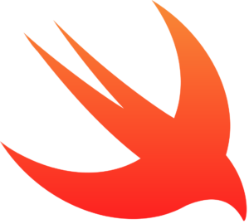Although many languages share similarities, each has its own syntax. Once a programmer learns the languages rules, syntax, and structure, they write the source code in a text editor or IDE. Then, the programmer often compiles the code into machine language that can be understood by the computer. Scripting languages, which do not require a compiler, use an interpreter to execute the script.

1. Swift:

Swift is Apple’s newest open-source, multi-paradigm programming language for iOS and OS X apps. Swift integrates Objective-C’s named parameters and object-oriented model, while including an advanced compiler, debugger and framework infrastructure.

**Why it is useful?**

Supports ‘playgrounds,’ a feature that lets programmers experiment and see immediate results

Easy to understand syntax

Ideal for writing production-ready code

1. 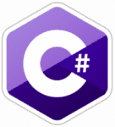C#:

Pronounced C-sharp (not C-hashtag), C# is a multi-paradigm programming language that features strong typing, imperative, declarative, functional, generic, object-oriented and component-oriented disciplines.

**Why it is useful?**

Similar to Java in capabilities

Ideal for beginners

The go-to for working on Microsoft apps

1. HTML (HyperText Markup Language):

HTML is the standard markup language used to create web pages; it ensures proper formatting of text and images (using tags) so that Internet browsers can display them in the ways they were intended to look.

**Why it is useful?**

HTML is used to create electronic documents (pages) displayed online. Visit any page and you will see an example of HTML in action. The diversity and complexity in the structure and appearance of today’s sites is made possible with HTML.

Features:

Easy to use and learn the basics of HTML

Free and accessible

Multiple versions available

**Screenshots:**

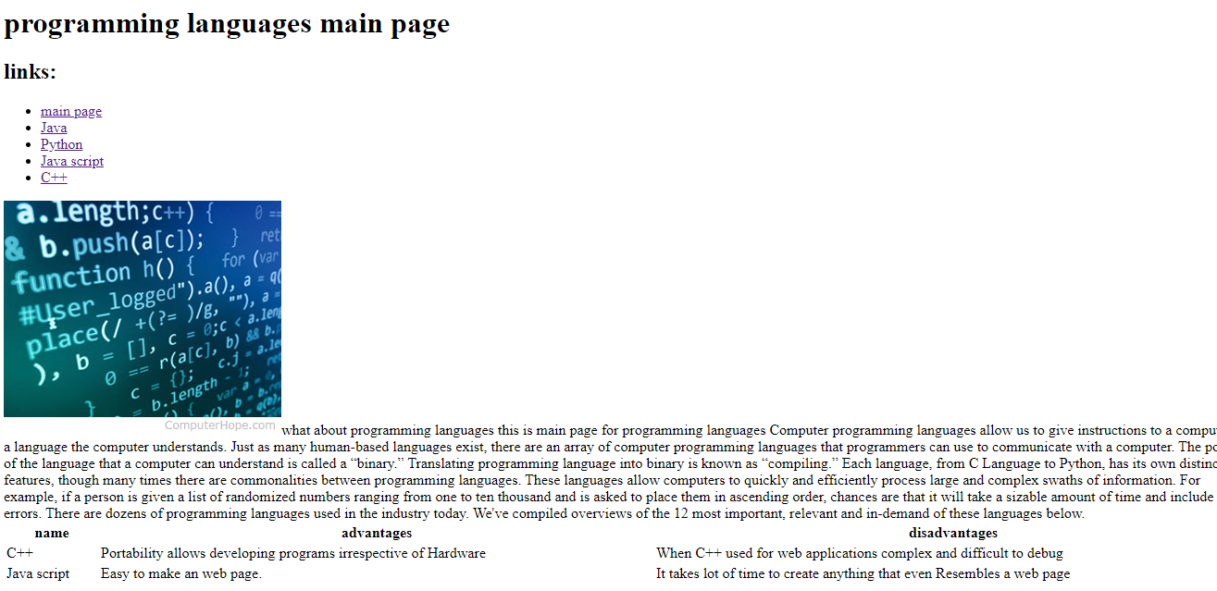

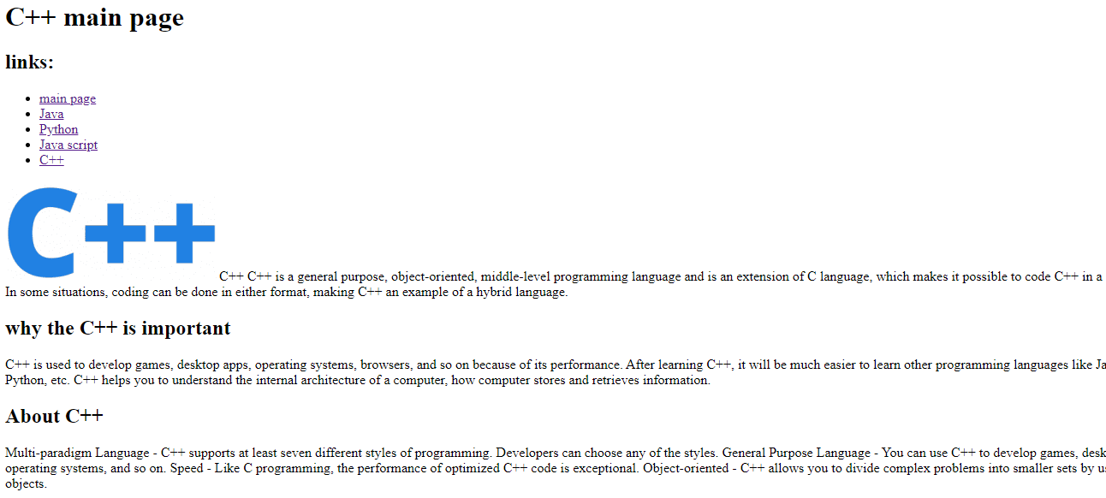

**Source code:**



